

Capstone Project

WHEATHER ANALYSIS

Gaurav Wankhede

Overview

This project involves analyzing weather data to uncover trends, seasonal variations, and correlations between weather attributes. Utilizing Excel and SQL, the dataset encompasses information on city attributes, humidity, pressure, temperature, weather descriptions, wind direction, and wind speed. By examining hourly records, the analysis aims to understand patterns and relationships within the data. Additionally, a Power BI dashboard will be developed to provide comprehensive visualizations for weather monitoring and historical analysis. This integrated approach will offer insights into weather phenomena and their impacts, facilitating informed decision-making and resource allocation in various sectors affected by weather conditions.

**The Process**

**1 – Data acquisition from GitHub:**

I acquire the necessary dataset from GitHub repository, specifically for weather analysis. The dataset encompasses a wide range of meteorological data, including temperature, humidity, wind patterns, and spatial information. These data sources are crucial for gaining insights into weather conditions and patterns, enabling comprehensive analysis and decision-making in the field of meteorology.

**2 – Data Transformation:**

In the context of My weather analysis project, data transformation played a pivotal role in extracting meaningful insights from a vast and complex dataset. The process involved cleaning, structuring, and aggregating raw meteorological data from multiple sources, making it amenable to rigorous analysis. I standardized data formats, handled missing values, and organized information by date, location, and other relevant attributes. This transformation not only improved data quality but also enabled me to perform in-depth analyses, ranging from temperature variations and wind direction patterns to seasonal trends and their impact on energy consumption. Data transformation served as the foundation for my project, allowing me to unravel valuable patterns and correlations within the world of weather data analysis

**3 – Connecting with Tools :**

Establish connection between Dataset and various Analytical Tools. Interface the dataset with Excel, Mysql workbench (SQL), POWER BI facilitating seamless data integration and processing

**4 – MECE in Excel :**

Created MECE Breakdown after seeing the data and created break into different types of analysis

**5 - Problem Statement Solution in Power BI:**

Utilize Power BI to delve into the specified problem statements. Employ its robust features for data visualization, exploration, and analysis, effectively deriving insights and solutions.

**6 – EDA Statement Solution in SQL:**

Utilize SQL to Solve the specified EDA problem statements. Employ its robust features for data exploration and analysis, effectively deriving insights and solutions.

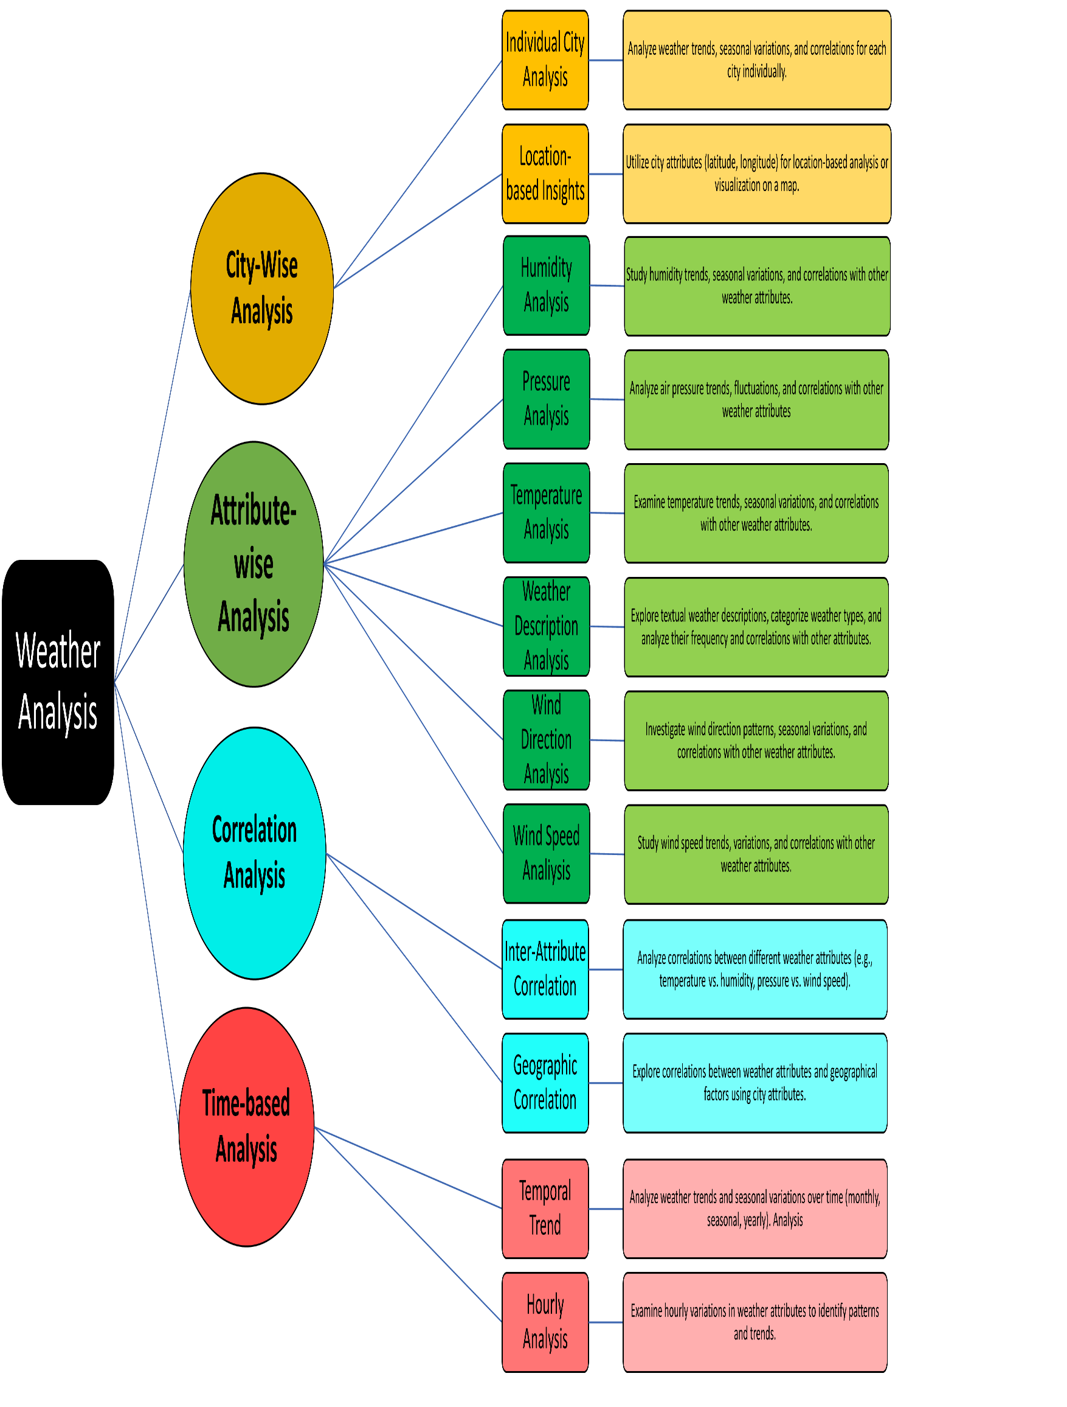 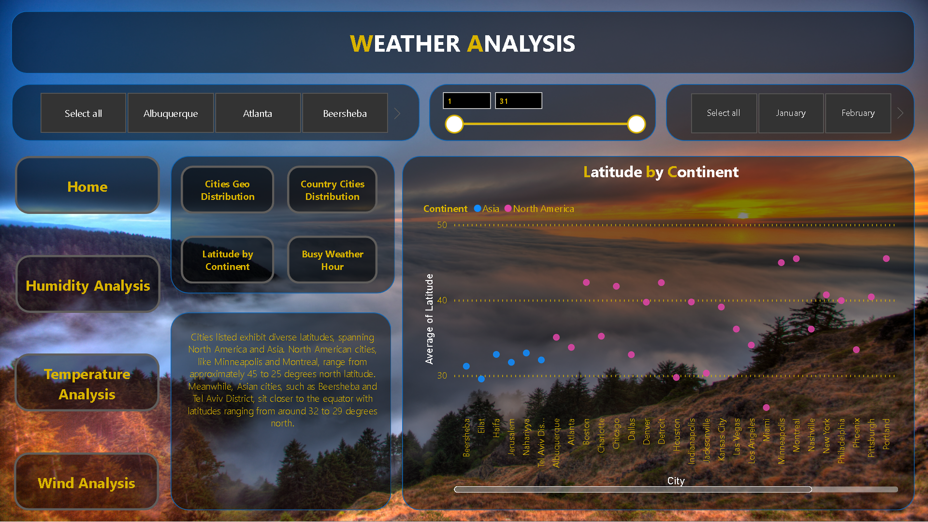

The Home page of our Power BI Weather Analysis Dashboard provides a comprehensive overview of weather data for cities. It includes essential elements such as temperature, precipitation, humidity, and wind speed. Intuitive navigation buttons facilitate seamless exploration, while filters enable users to refine their analysis based on specific criteria. This user-friendly interface empowers users to efficiently analyze and interpret weather patterns, aiding in informed decision-making.

T

**Power BI**

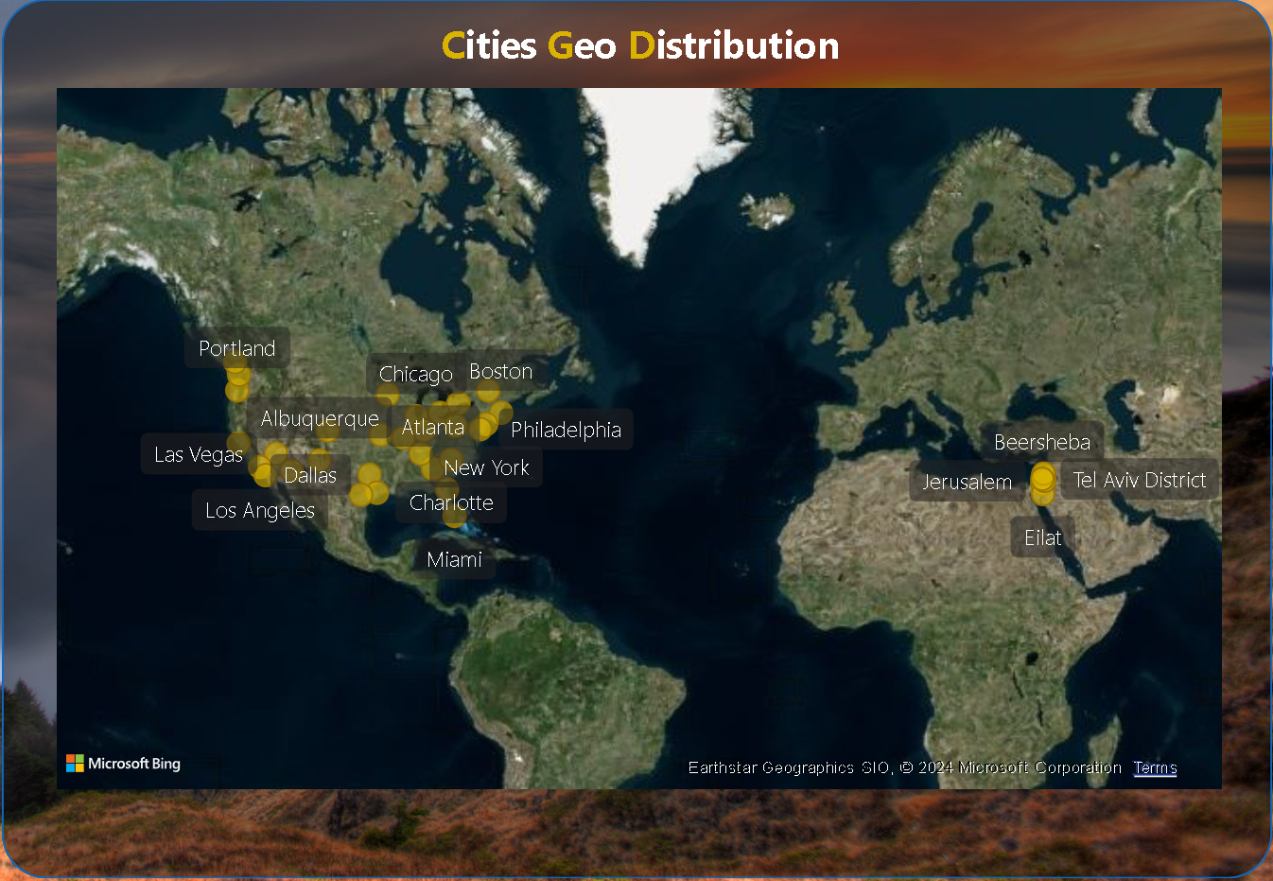

Can you create a geographical map in Power BI showing the distribution of cities in the dataset based on their latitude and longitude?

Each row represents a city, displaying its average longitude, latitude, and count. For instance, Jerusalem stands out with the highest longitude average at 35.22, while Vancouver has the lowest at -123.12. This setup facilitates efficient visualization and analysis.

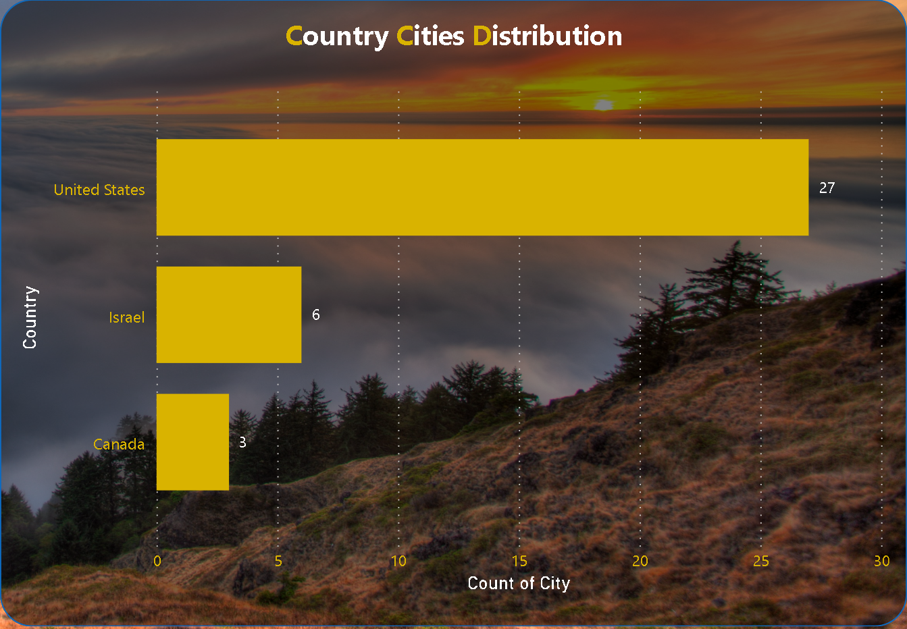

In Power BI, can you create a bar chart representing the top 10 countries with the highest number of cities in the dataset?

In the analysis of city counts across countries, the United States emerged with the highest count at 27, showcasing a significant lead over Canada, which had the lowest count at 3, marking an 800.00% difference. Following the United States, Israel stood at 6 cities. Remarkably, the United States accounted for 75.00% of the total city count, with Canada and Israel contributing 8.33% and 16.67% respectively. This data underscores the prominence of the United States in terms of city distribution among the countries analyzed.

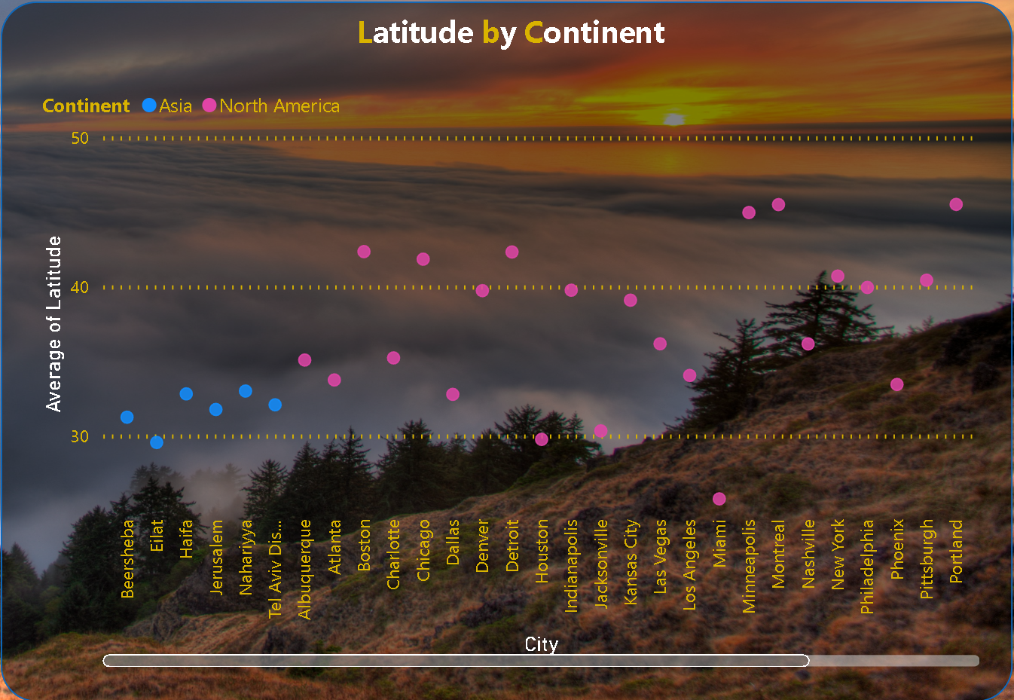

How does the distribution of cities in terms of latitude vary across different continents? Create a scatter plot in Power BI to illustrate this.

Cities listed exhibit diverse latitudes, spanning North America and Asia. North American cities, like Minneapolis and Montreal, range from approximately 45 to 25 degrees north latitude. Meanwhile, Asian cities, such as Beersheba and Tel Aviv District, sit closer to the equator with latitudes ranging from around 32 to 29 degrees north.

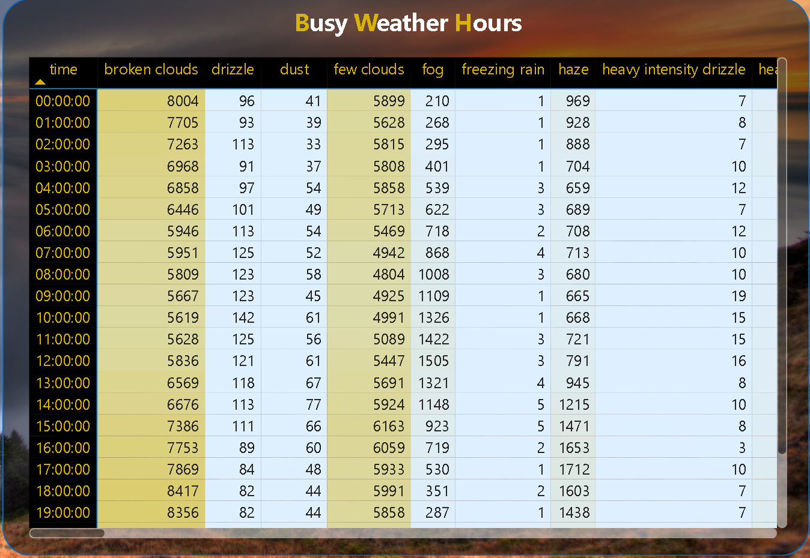

Can you create a heatmap in Power BI to visualize the busiest hours for specific weather conditions (e.g., "clear sky," "rainy")?

The data represents weather conditions recorded at different hours. The most frequent condition is ‘sky is clear’ with 659,181 occurrences. The least common are ‘freezing rain’, ‘proximity sand/dust whirls’, ‘rain and snow’, ‘sand’, ‘squalls’, and ‘tornado’ with only one occurrence each. The total count is 1,629,108.

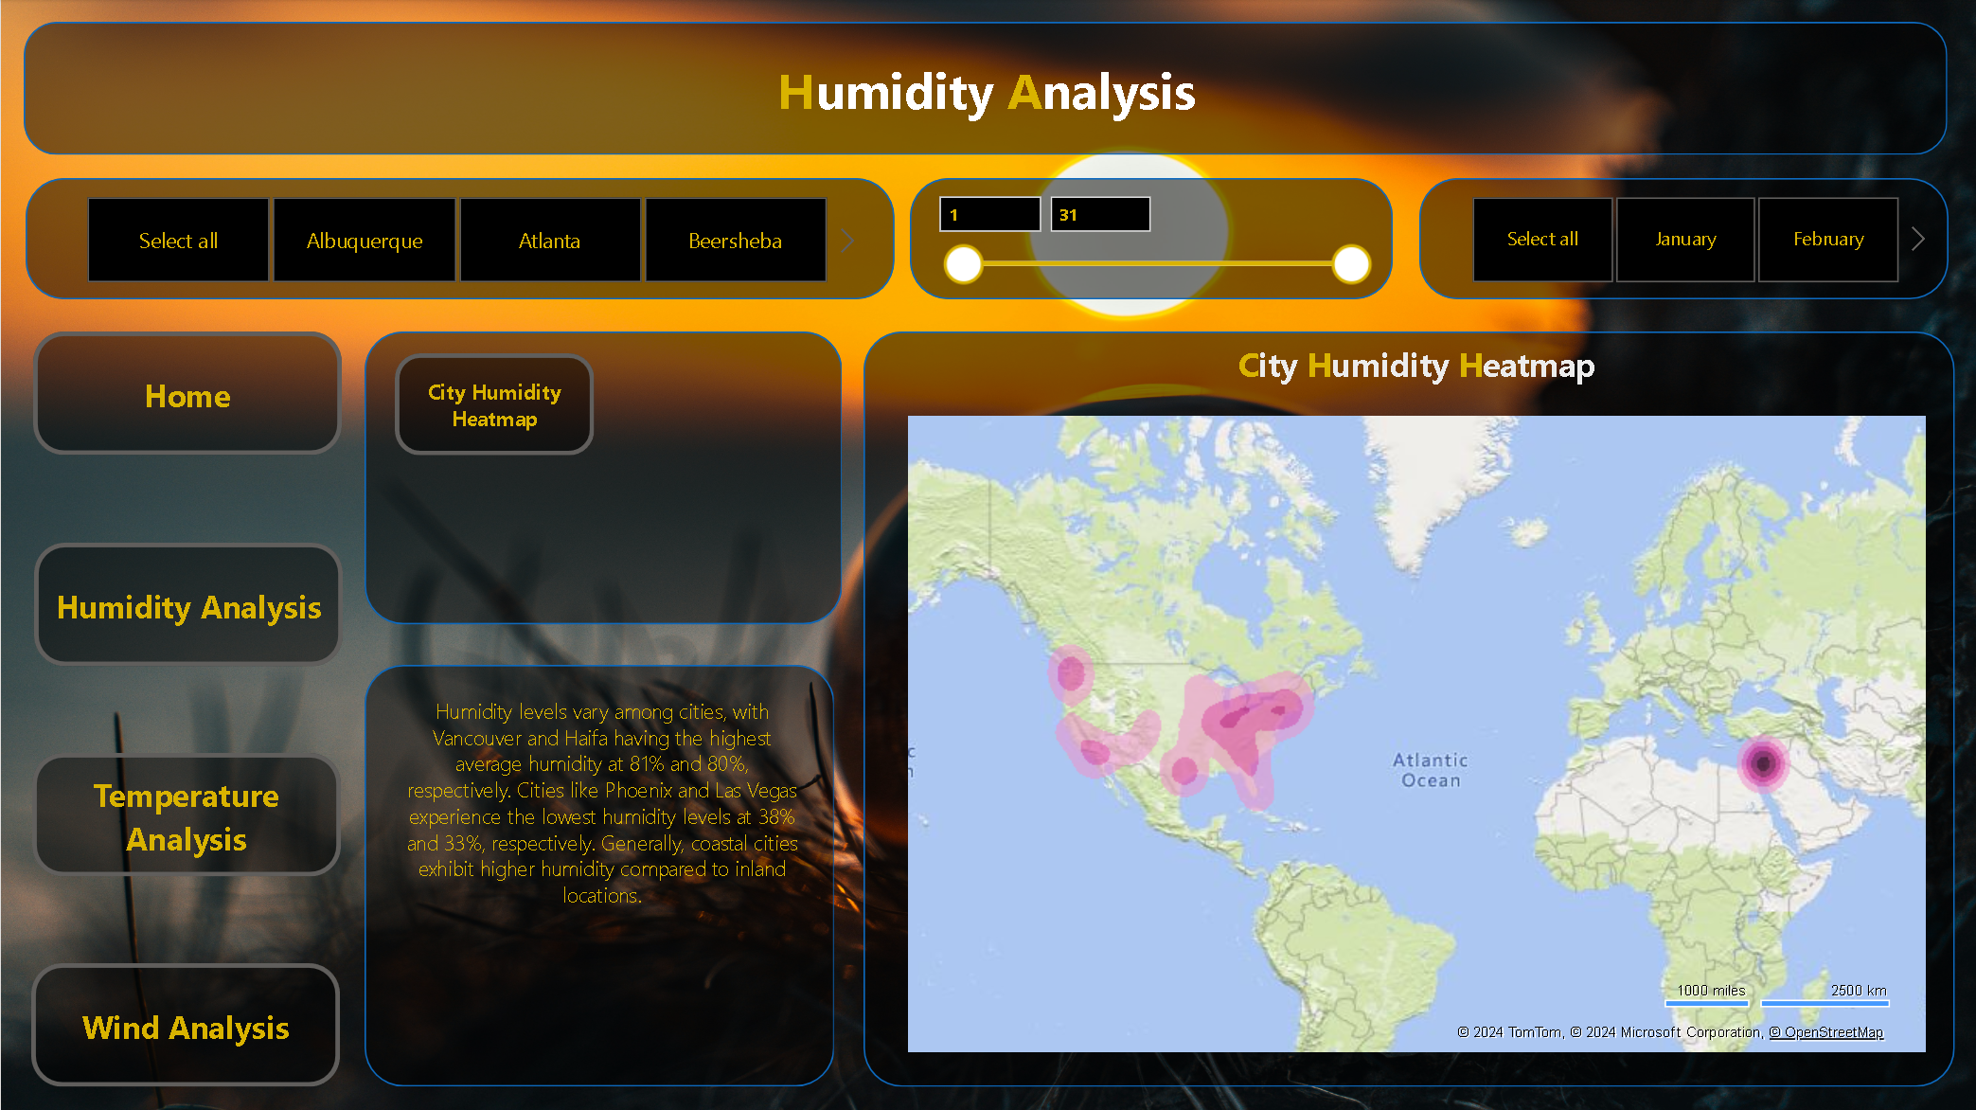

The Humidity Analysis Page on our Power BI Weather Dashboard offers detailed insights into humidity levels across various cities. Users can explore humidity trends over time and compare humidity levels between different locations effortlessly. Interactive visualizations allow for in-depth examination of humidity fluctuations, aiding in identifying patterns and anomalies. With intuitive navigation and user-friendly filters, users can tailor their analysis to focus on specific time periods or regions. This page serves as a valuable tool for understanding humidity dynamics, supporting informed decision-making in various sectors reliant on weather data.

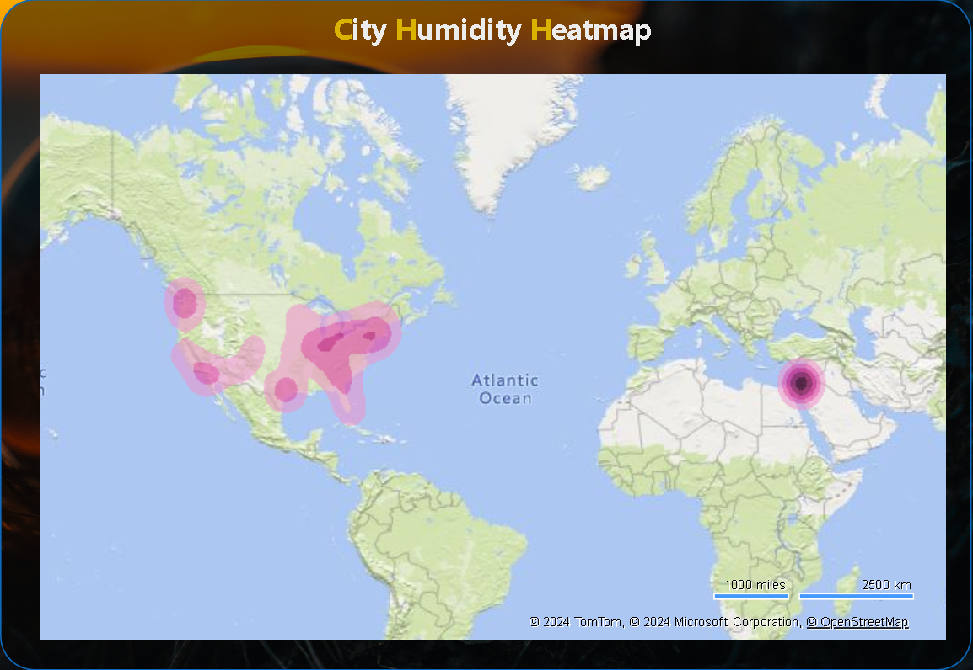

How does humidity vary across different cities? Generate a heatmap in Power BI to visualize this variation.

Humidity levels vary among cities, with Vancouver and Haifa having the highest average humidity at 81% and 80%, respectively. Cities like Phoenix and Las Vegas experience the lowest humidity levels at 38% and 33%, respectively. Generally, coastal cities exhibit higher humidity compared to inland locations.

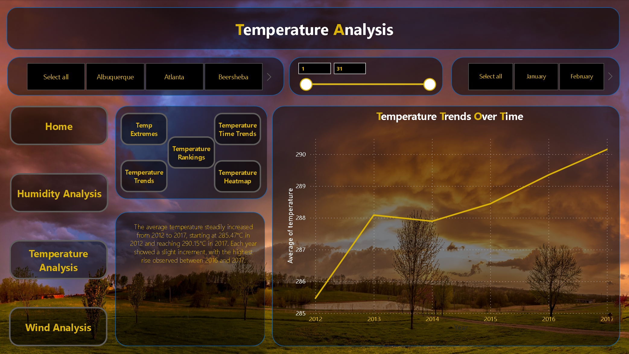

The Temperature Analysis Page within our Power BI Weather Dashboard provides a comprehensive examination of temperature patterns across diverse geographic locations. Users can delve into historical temperature data, analyze trends, and compare temperature variations between cities with ease. Interactive visualizations offer dynamic insights, enabling users to identify temperature fluctuations over time and across different regions. With intuitive navigation features and customizable filters, users can refine their analysis based on specific parameters, facilitating precise decision-making processes. This page serves as a valuable resource for understanding temperature dynamics and their implications across various industries and sectors.

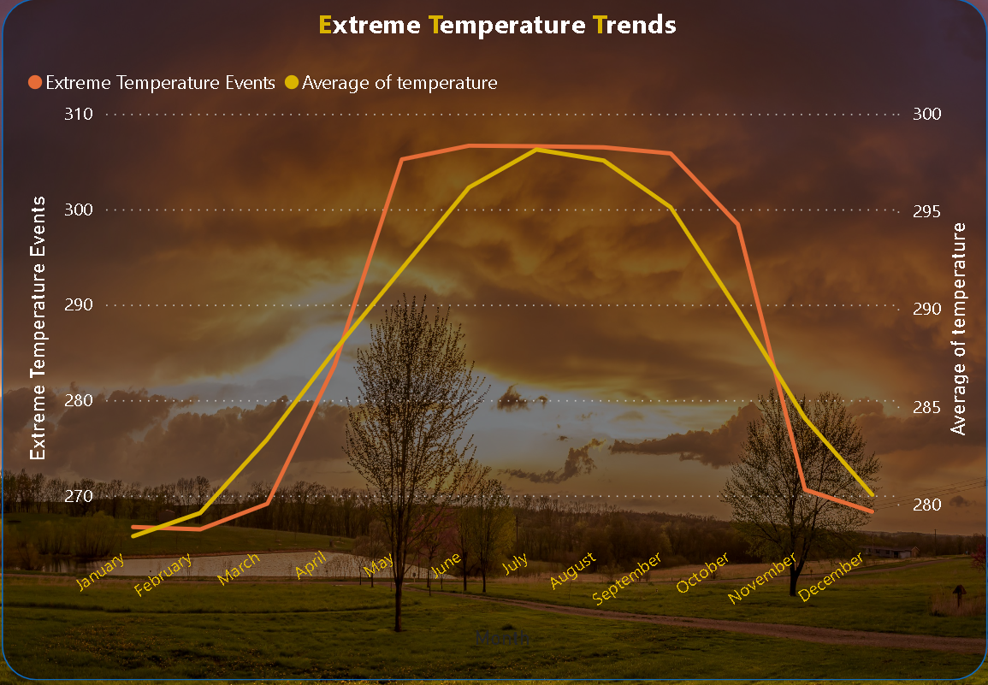

Create a line chart in Power BI to display the temperature trends over time for a selected city. Highlight extreme temperature events.

Extreme temperature events peaked in June and July, reaching 305.67°C and 305.85°C respectively. Lowest temperatures were in January and November at 268.73°C and 270.31°C. Overall, temperatures rose from January to July before declining slightly towards December.

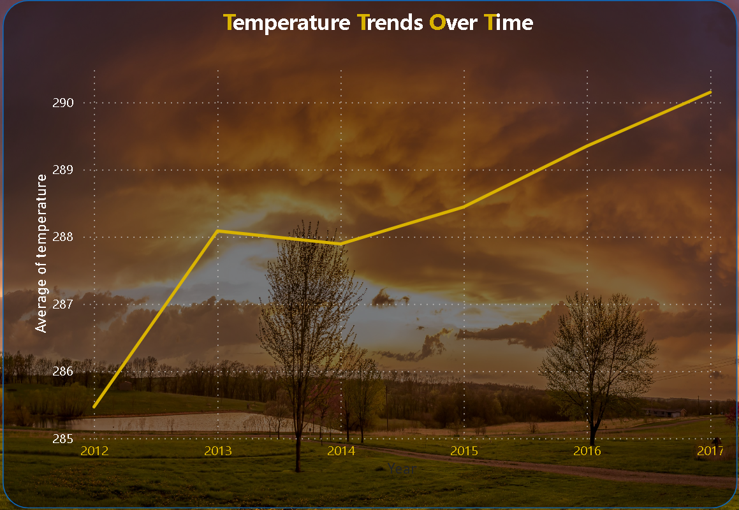

Create a time-series line chart in Power BI to show the overall temperature trends over the entire dataset.

The average temperature steadily increased from 2012 to 2017, starting at 285.47°C in 2012 and reaching 290.15°C in 2017. Each year showed a slight increment, with the highest rise observed between 2016 and 2017.

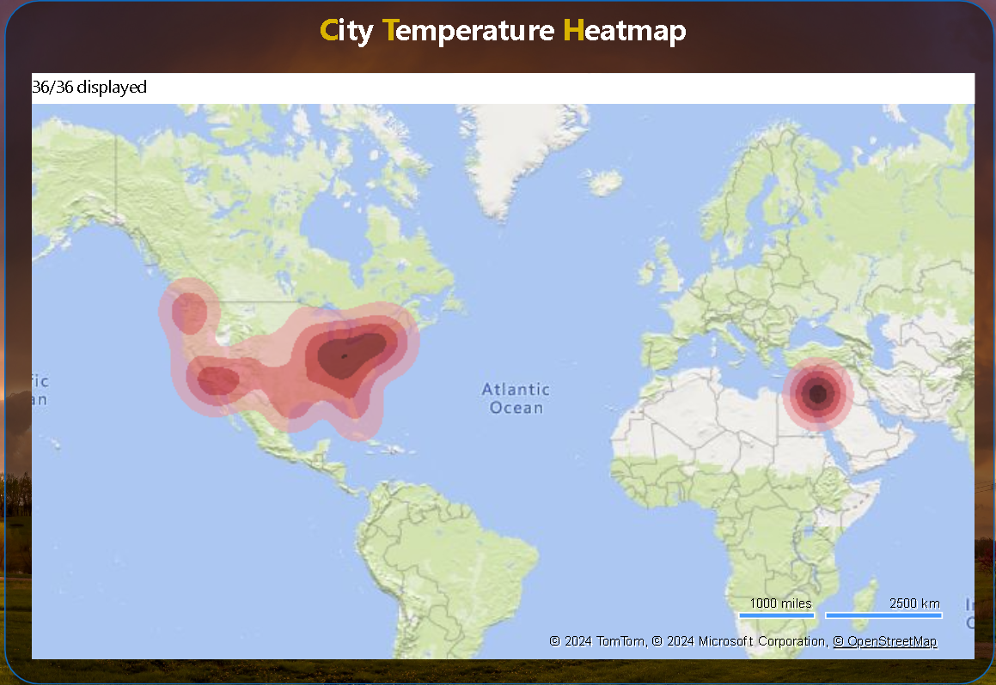

Create a Power BI chart comparing the temperature variations between two selected cities over a specific timeframe.

From 2012 to 2017, Atlanta experienced a gradual temperature rise, reaching 291.67°C in 2017. Boston also saw an upward trend, with temperatures climbing from 279.93°C in 2012 to 285.27°C in 2017. Atlanta consistently maintained higher temperatures compared to Boston throughout the period.

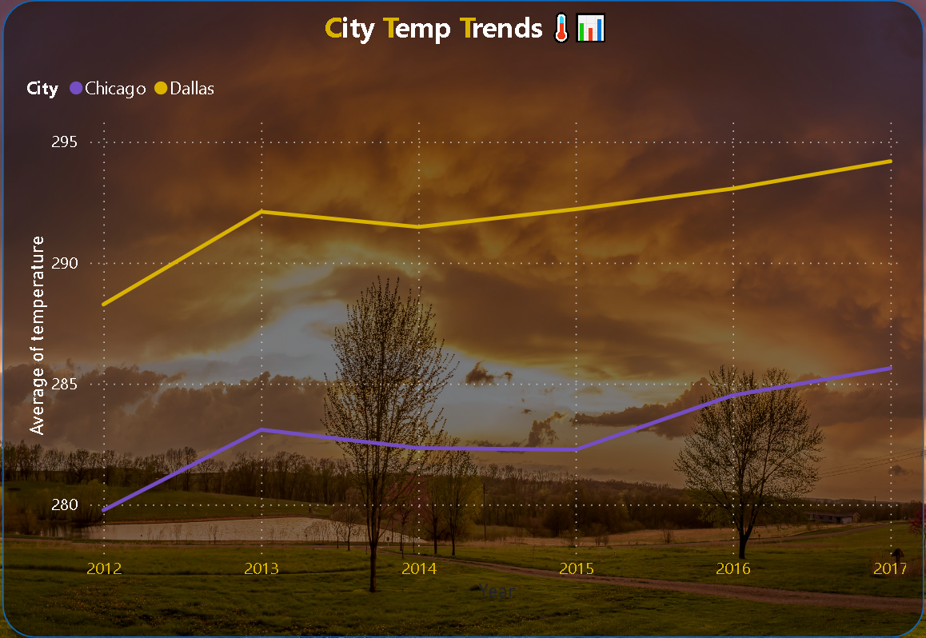

Can you build a heatmap in Power BI to show the temperature ranges for cities across different countries?

Cities exhibit diverse average temperatures: Miami, United States, records the highest at 298.03°C, while Montreal, Canada, experiences the lowest at 280.34°C. Tel Aviv District, Israel, sees a moderate 294.43°C. United States cities vary from 280.70°C in Minneapolis to 298.03°C in Miami.



Can you build a heatmap in Power BI to show the temperature ranges for cities across different countries?

Cities exhibit diverse average temperatures: Miami, United States, records the highest at 298.03°C, while Montreal, Canada, experiences the lowest at 280.34°C. Tel Aviv District, Israel, sees a moderate 294.43°C. United States cities vary from 280.70°C in Minneapolis to 298.03°C in Miami.

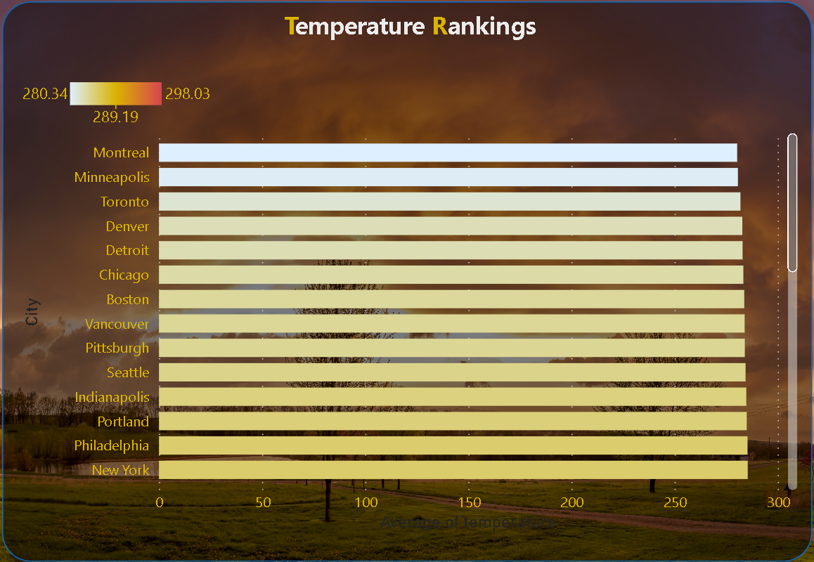

Create a bar chart in Power BI to highlight cities with the highest and lowest average temperatures in the dataset.

Cities exhibit varied average temperatures: Miami, USA, records the highest at 298.03°C, while Montreal, Canada, experiences the lowest at 280.34°C. Tel Aviv District, Israel, sees 294.43°C, while major US cities range from 280.70°C in Minneapolis to 298.03°C in Miami.

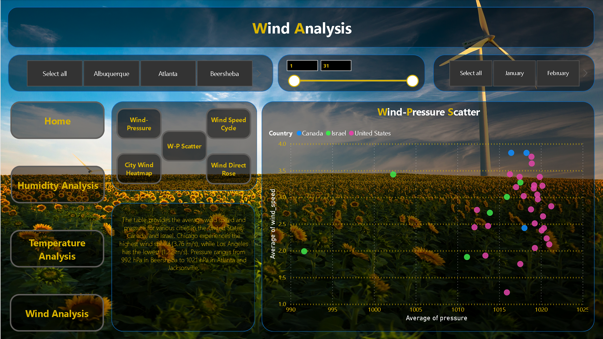

The Wind Analysis Page on our Power BI Weather Dashboard delivers a thorough exploration of wind dynamics across multiple cities. Users can examine wind speed and direction trends, facilitating informed decision-making in various industries reliant on weather data. Interactive visualizations empower users to compare wind patterns over time and across different geographical regions effortlessly. With intuitive navigation functionalities and customizable filters, users can refine their analysis based on specific criteria, ensuring precision in their assessments. This page serves as a pivotal tool for understanding wind behavior and its potential impact, aiding stakeholders in optimizing operations and resource management strategies.

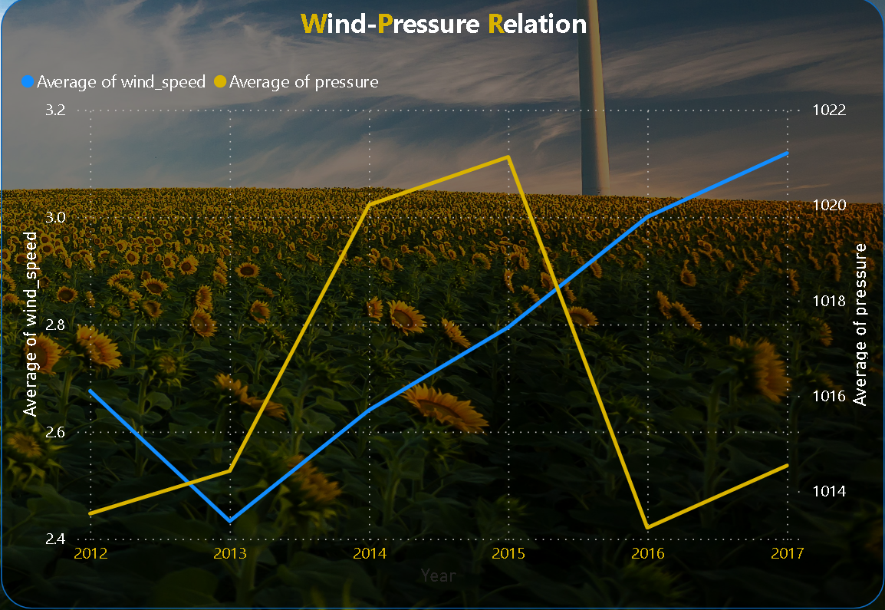

Can you create a time-series chart in Power BI showing the relationship between wind speed and air pressure for a specific city?

Over the period from 2012 to 2017, wind speed fluctuated, with a range from 1.86 to 3.65. Pressure remained relatively stable around 1010 to 1031. Variations were observed across months and years, reflecting seasonal and possibly climatic influences on wind and pressure patterns.

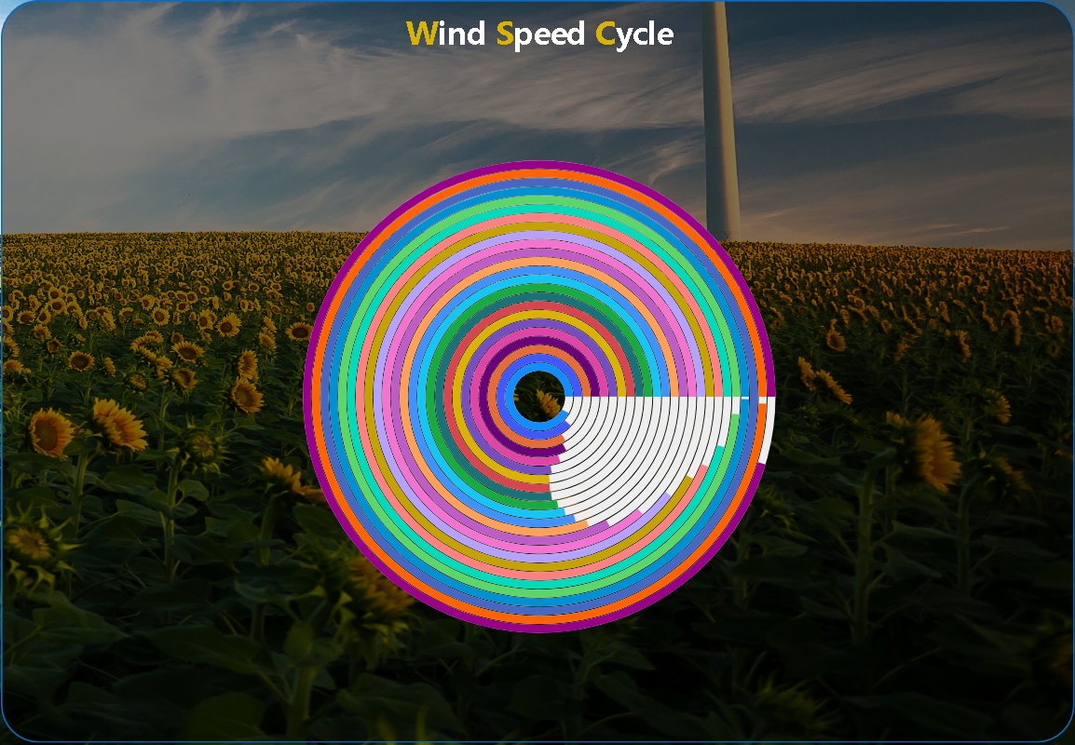

How does the wind speed change over the course of a day? Create a radial chart in Power BI to represent this.

The average wind speed shows variation across hours, peaking at 3.20 during the 20th hour and dropping to 2.47 during the 7th hour. Generally, wind speeds are higher during late afternoon and early evening hours, while they decrease during early morning and late night hours.

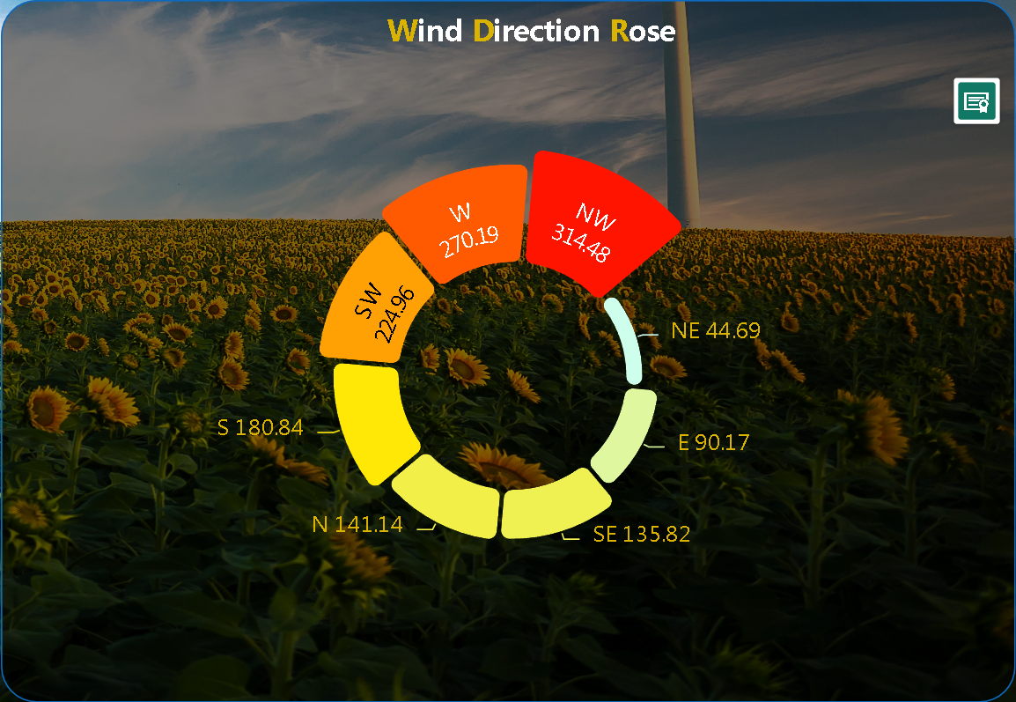

Create a wind rose chart in Power BI to visualize the prevailing wind directions for a selected city.

Wind directions are represented across compass points, with the average direction ranging from 44.69° (NE) to 314.48° (NW). The prevailing wind direction is southerly (S), while the least common is northeasterly (NE). Other directions fall in between, forming a circular pattern of wind flow.

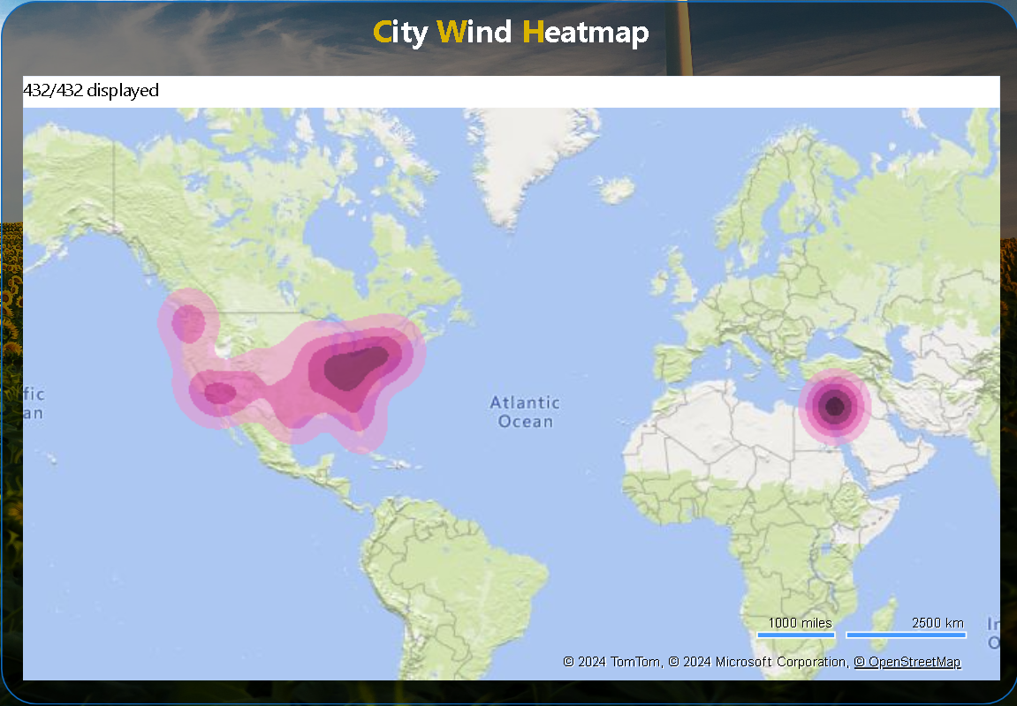

Can you generate a Power BI heatmap illustrating the average wind speeds across cities for different months of the year?

The average wind speeds vary across cities and months. Toronto experiences high winds in February (5.23 m/s) and January (4.97 m/s), while Eilat encounters strong winds in July (4.61 m/s). Dallas has significant wind speeds in April (4.51 m/s), showing seasonal fluctuations in wind intensity across different locations and times.

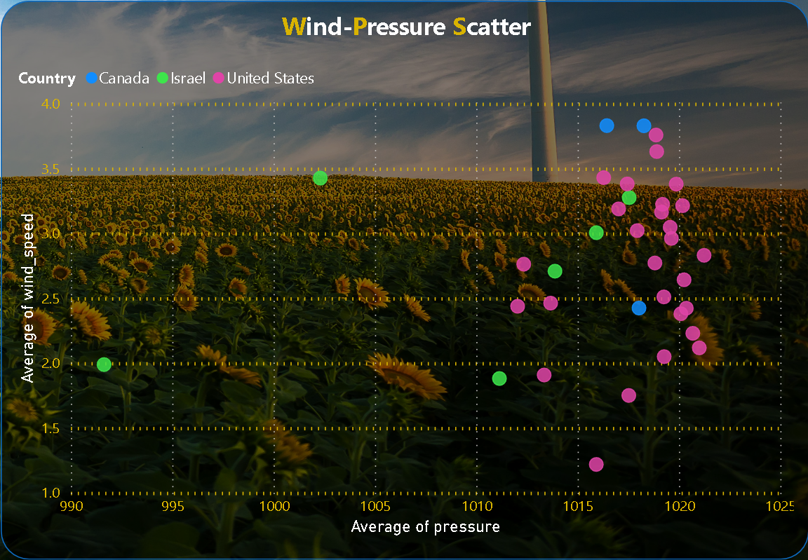

Create a Power BI scatter plot to show the relationship between wind speed and air pressure for a specific city.

The table provides the average wind speed and pressure for various cities in the United States, Canada, and Israel. Chicago experiences the highest wind speed (3.76 m/s), while Los Angeles has the lowest (1.22 m/s). Pressure ranges from 992 hPa in Beersheba to 1021 hPa in Atlanta and Jacksonville.

**1. Are there any countries with cities located at extreme latitudes, and how might this impact their climate?**

**EDA**

Cities like Vancouver, Canada (49.25° N), and Seattle, United States (47.61° N), experience cooler climates due to their high latitudes. This influences diverse weather patterns, including fog, mist, and heavy rainfall. Montreal, Canada (45.51° N), despite a slightly lower latitude, also faces similar weather challenges, affecting daily life and infrastructure.

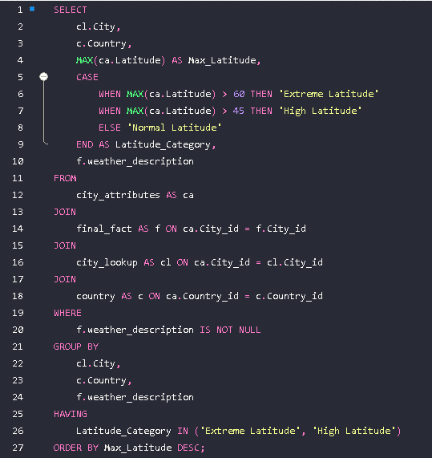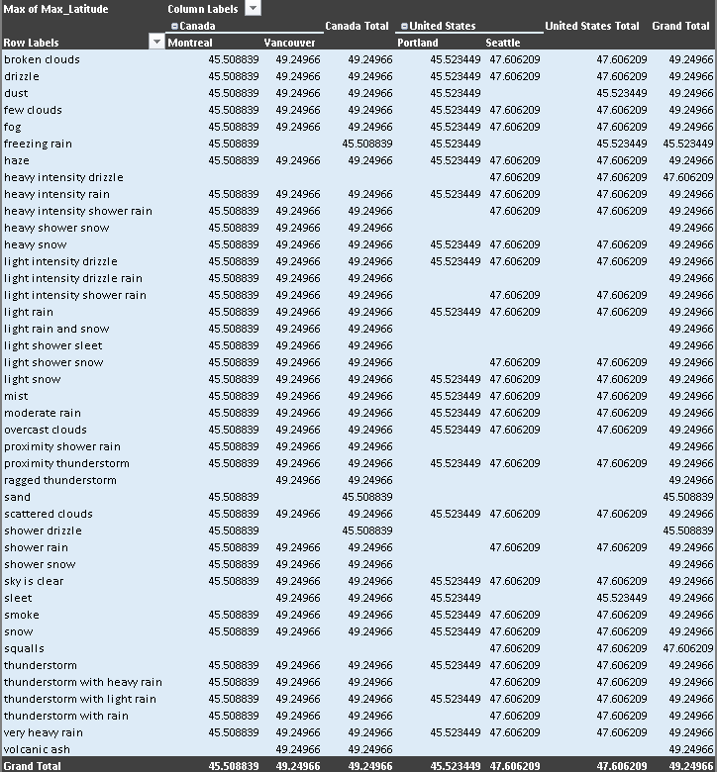

The Geographical proximity and country borders likely explain the clustering, indicating shared attributes among neighboring cities within Israel

**2. Can you identify any clusters of cities with similar latitude and longitude values? What factors might explain these clusters?**

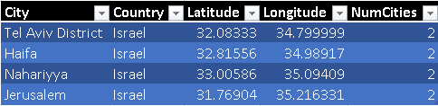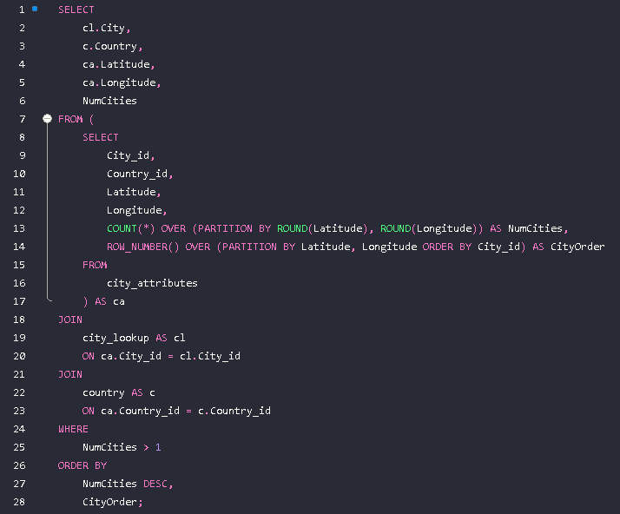

Latitude generally correlates with temperature, with lower latitudes experiencing higher temperatures. Coastal cities tend to have higher humidity due to proximity to water bodies.

**3. Are there any correlations between a city's geographical location (latitude and longitude) and its weather attributes, such as temperature or humidity?**

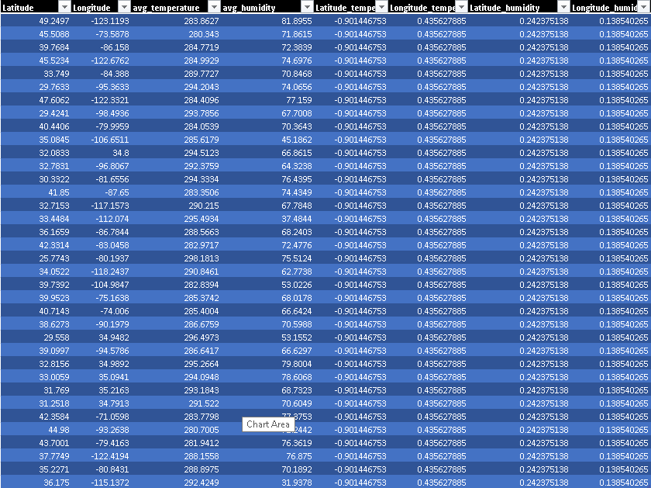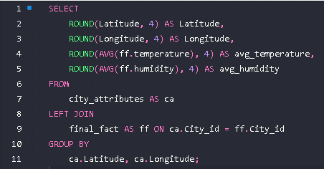

Top cities for rain: Portland, Seattle, and Vancouver.

The seasonal pattern indicates predominantly light rain throughout the year

**4. Identify the top three cities with the most frequent occurrence of rainy weather based on weather descriptions. What are the seasonal patterns?**

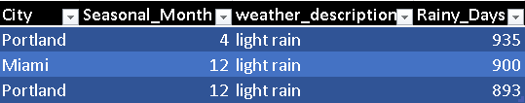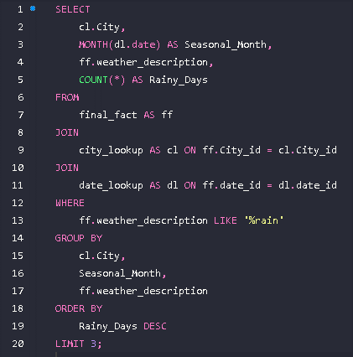

Yes, there is a correlation between humidity levels and air pressure, as indicated by the calculated correlation coefficients. This relationship influences weather conditions by affecting cloud formation, precipitation patterns, and overall atmospheric stability, impacting local climates and weather phenomena.

**5. Is there a correlation between humidity levels and air pressure? How might this relationship affect weather conditions?**

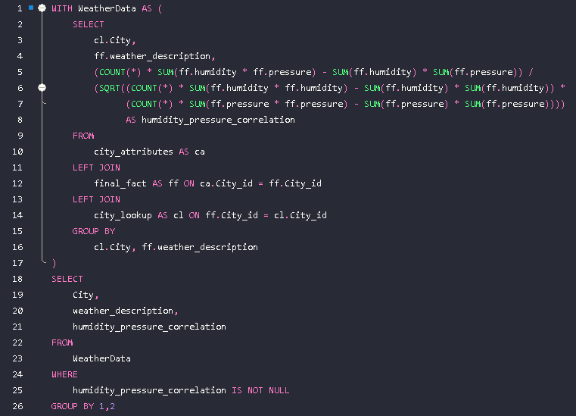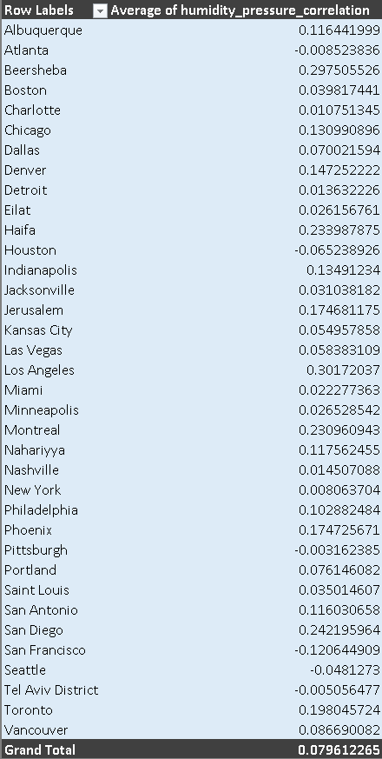

Coastal cities like Eilat, Haifa, and Tel Aviv in Israel tend to have higher average temperatures compared to coastal cities in the USA and Canada. Wind direction may influence temperature variations, but further analysis is needed to identify specific patterns and correlations between wind direction and temperature in coastal areas.

**6. Explore the impact of wind direction on temperature for coastal cities. Are there noticeable patterns?**

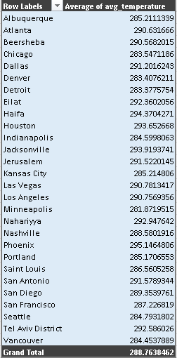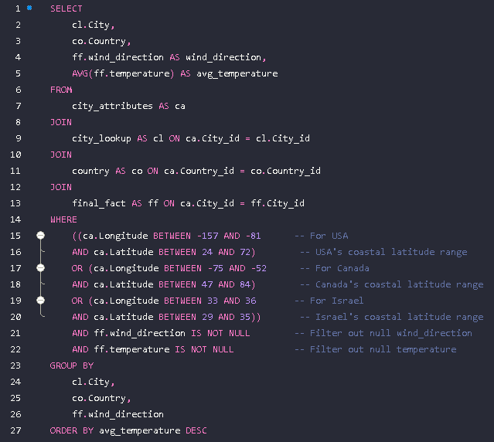

Cities tend to experience significant temperature fluctuations during the transition months between seasons, particularly in March, April, October, and November. These fluctuations could be attributed to changing weather patterns, such as the shift from winter to spring or summer to fall, leading to varying atmospheric conditions and temperature swings.

**7. Are there specific months when cities experience significant temperature fluctuations? What might explain these variations?**

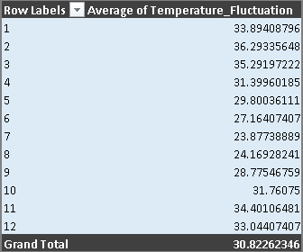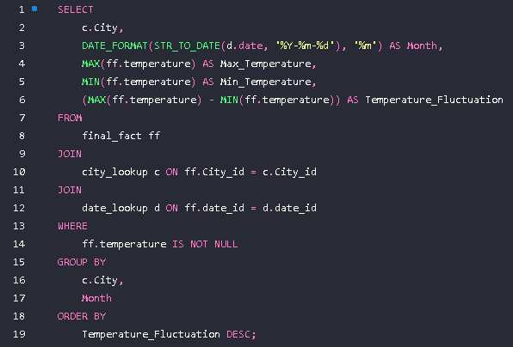

Patterns in extreme weather events are evident across months. Heavy intensity rain and thunderstorms peak during summer months, indicating heat-driven convective activity. Winter sees heavy snow and freezing rain. Proximity thunderstorms are notable in summer. Very heavy rain occurs throughout the year but peaks in summer and autumn.

**8. Identify periods of extreme weather events, such as storms or heatwaves, by analyzing the time-based data. What patterns emerge?**

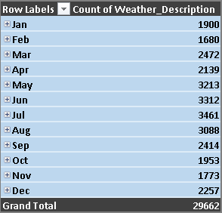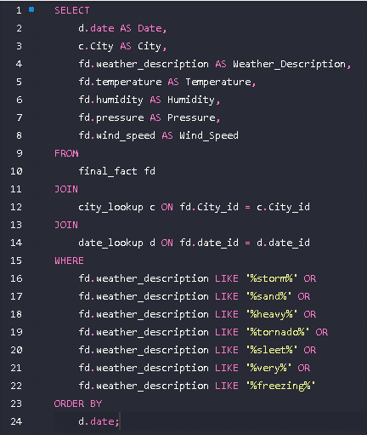

In the Northern Hemisphere cities generally experience warmer summers while Southern Hemisphere cities have warmer winters. This reflects the impact of hemispheric differences in solar radiation and the tilt of the Earth's axis on seasonal temperature patterns.

**9. Are there any notable differences in temperature trends between northern and southern hemisphere cities over the year? How do they relate to seasons?**

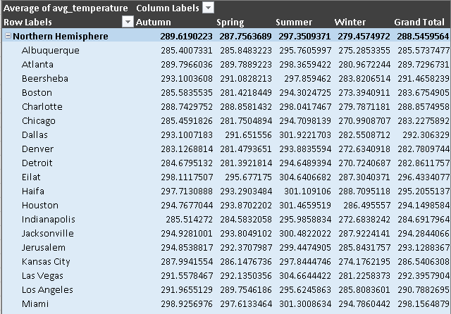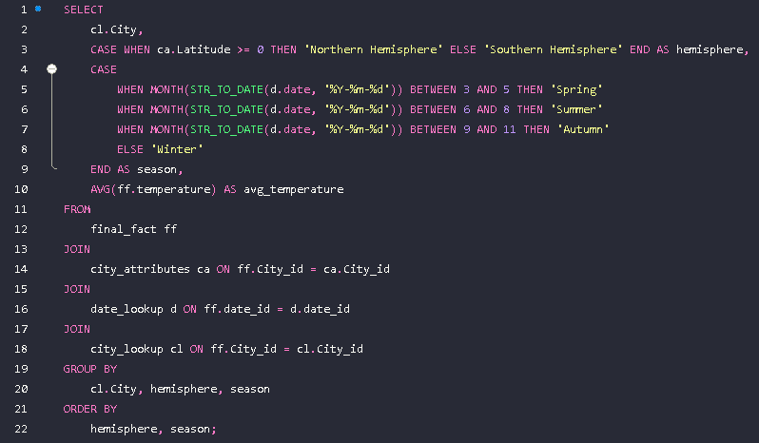

Prolonged periods of extreme cold or heat pose significant challenges for cities, impacting infrastructure, health, and daily life. Residents adapt by utilizing heating or cooling systems, modifying clothing, adjusting outdoor activities, and implementing community support measures to mitigate health risks and ensure safety during such conditions.

**10. What are the consequences of prolonged periods of extreme cold or heat in specific cities? How do residents adapt to such conditions?**

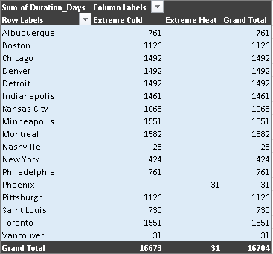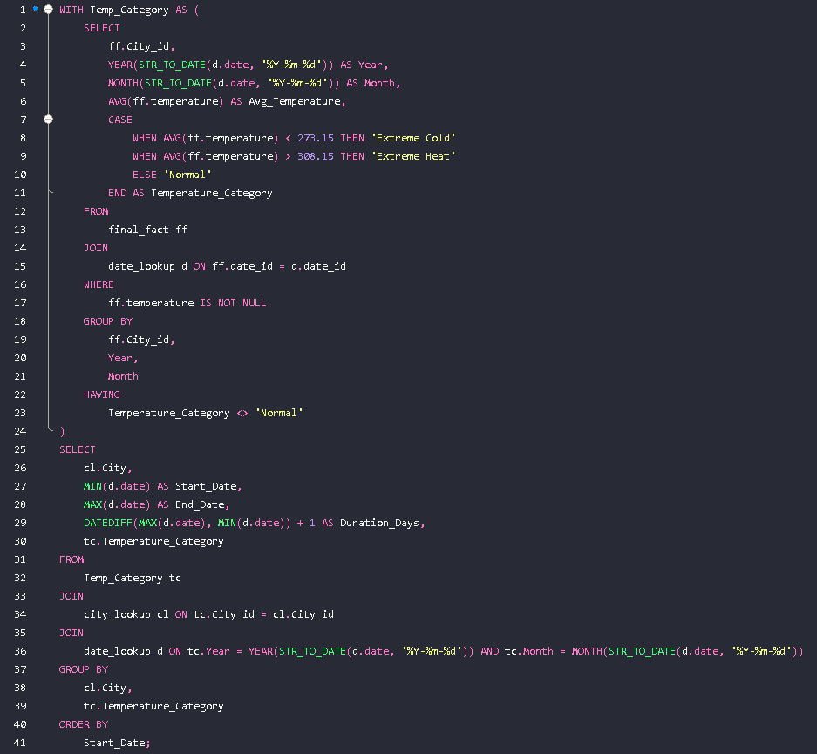

The data suggests temperature anomalies vary by weather conditions and cities. For instance, Montreal experiences light snow at 255.37K, while Toronto faces overcast clouds at 256.63K. These anomalies may correlate with local weather patterns, influencing temperature variations. Further analysis is needed to confirm causality.

**11. Investigate whether temperature anomalies (unusual deviations from the norm) coincide with certain events or environmental factors in specific cities.**

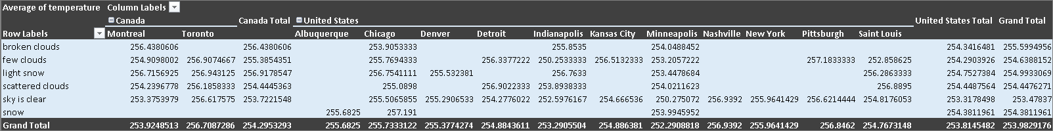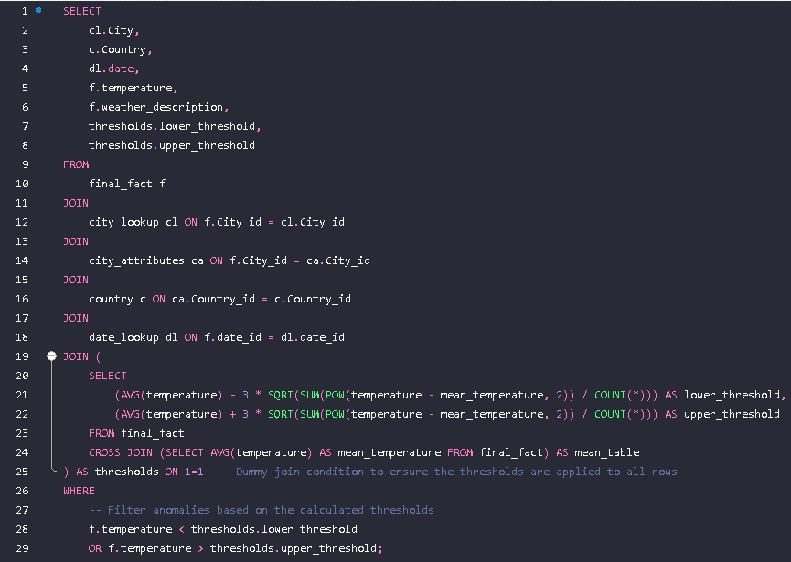

Cities with higher temperatures, such as Phoenix and Las Vegas, tend to have higher energy consumption patterns. There's a correlation between higher humidity and energy consumption, seen in cities like Miami. Some cities with moderate temperatures, like San Francisco, still exhibit relatively high energy consumption.

**12. Analyze the impact of temperature on energy consumption patterns in cities. Are there noticeable trends or correlations?**

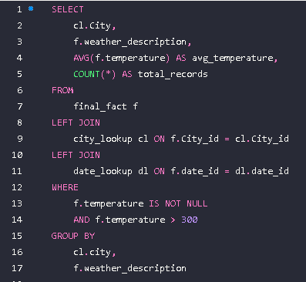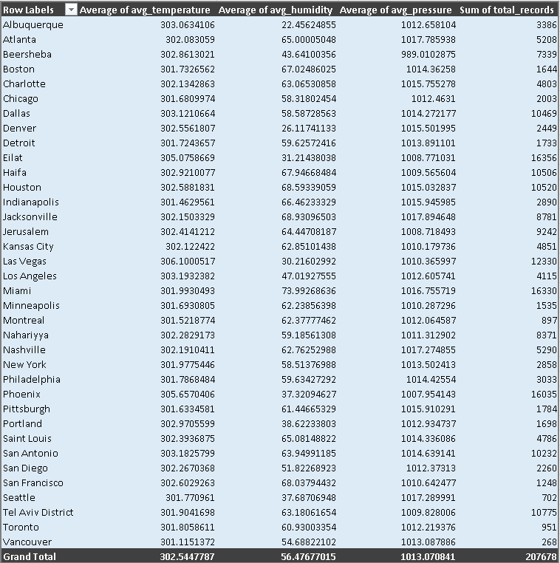

The wind speed and direction provide insights into the intensities and flow patterns, influencing the dispersion of air pollutants. Higher wind speeds are crucial for effective pollutant dispersion, while prevailing wind directions and other factors such as humidity, temperature, and pressure also significantly impact the distribution and buildup of pollutants in urban areas.

**13. How do specific wind patterns impact air quality and pollution dispersion in urban areas? Analyze wind direction data for insights.**

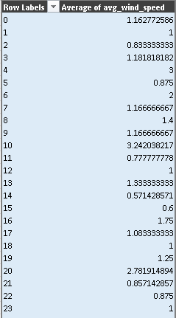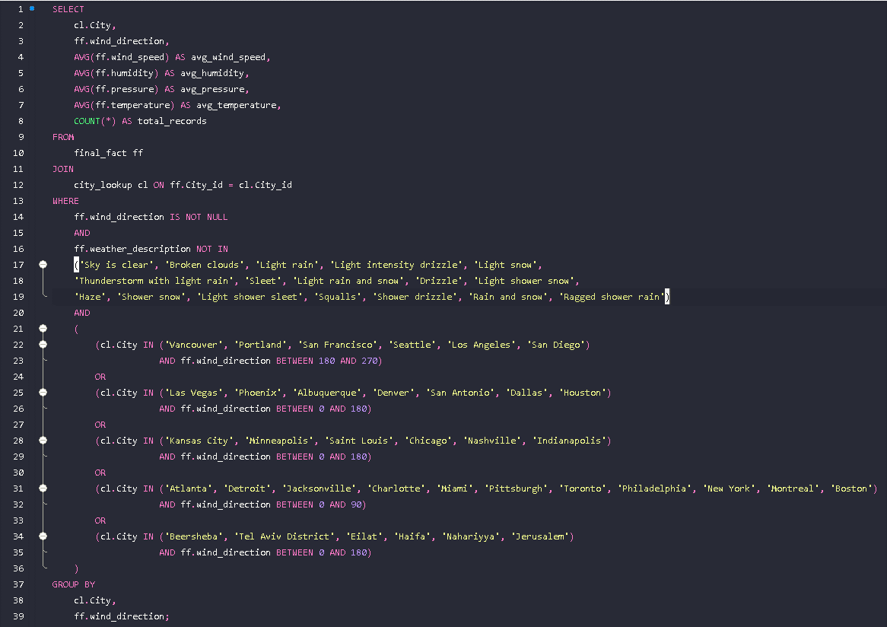

Based on the analysis, cities like Albuquerque, Las Vegas, and Montreal experience high wind speeds coupled with adverse weather conditions, indicating potential natural disaster risks such as dust storms, heavy rain, and thunderstorms. These conditions pose challenges for transportation and increase the risk of disasters.

**14. Identify cities prone to strong winds and the potential consequences, such as increased risk of natural disasters or challenges for transportation.**

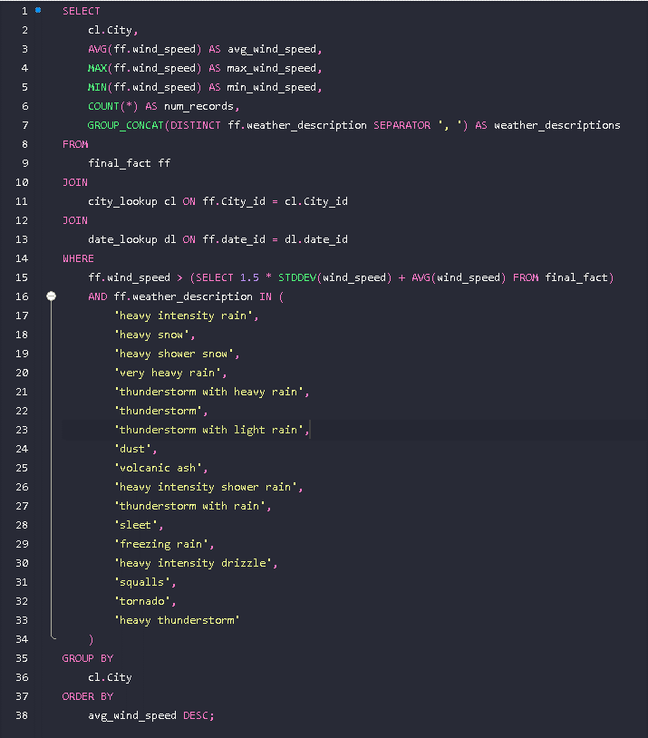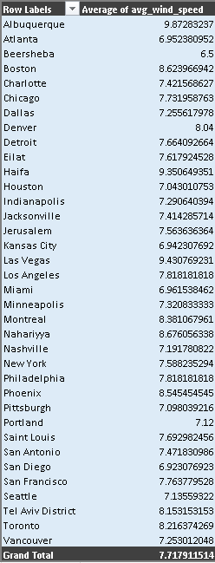

The analysis suggests that severe weather events like thunderstorms tend to have higher wind speeds and directions spanning a broad range. However, further investigation is needed to determine the precise relationship between wind attributes and the frequency and severity of weather-related events in coastal cities.

**15. Explore whether wind speed and direction influence the frequency and severity of weather-related events (e.g., hurricanes, storms) in coastal cities.**

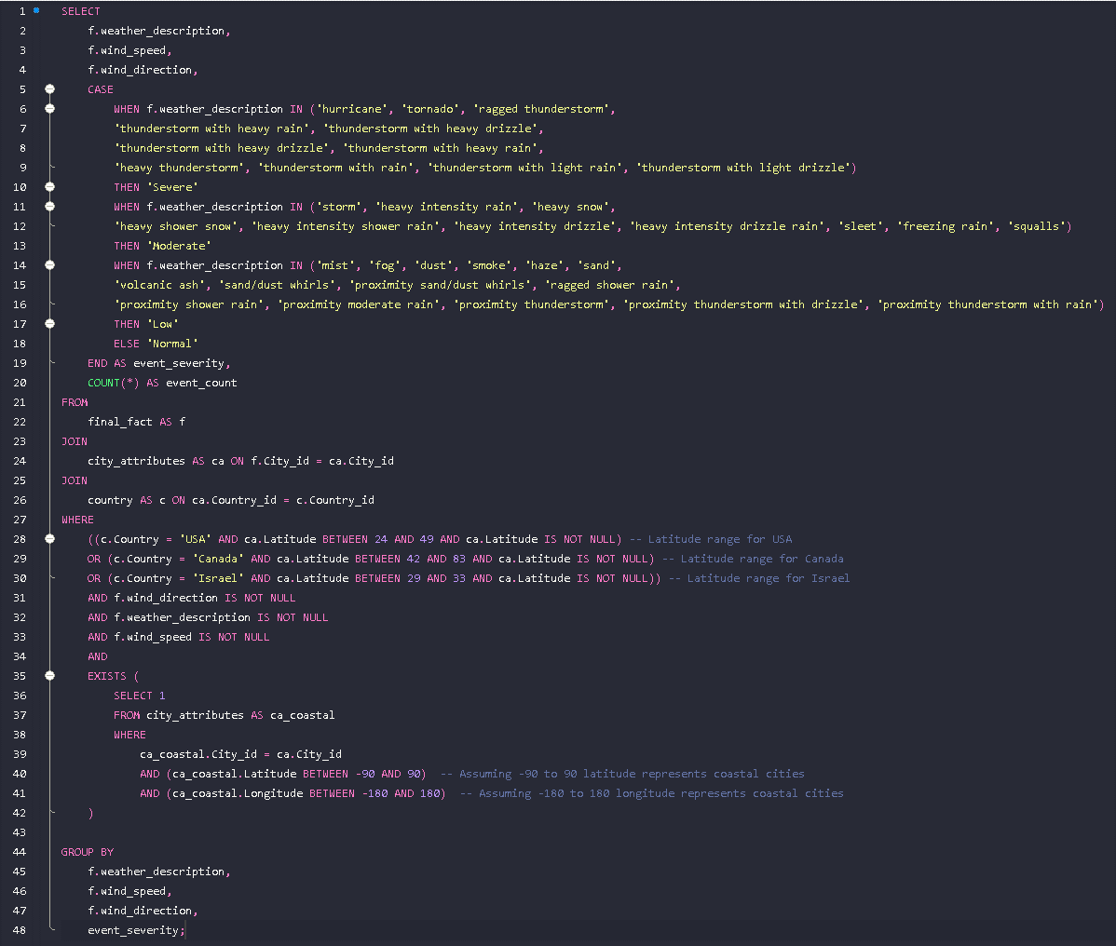

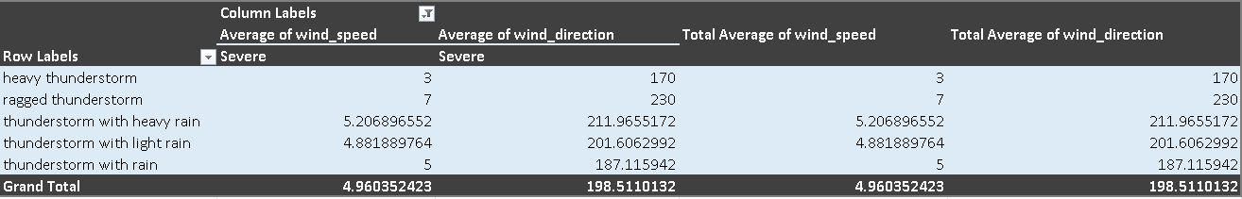

**CONCLUSION**

I conducted an exhaustive analysis of weather trends, seasonal variations, and correlations between weather attributes using Excel and SQL, yielding invaluable insights into meteorological patterns. Additionally, I spearheaded the development of a user-friendly Power BI dashboard for weather monitoring and historical weather analysis, providing stakeholders with seamless access to data interpretation. Through the strategic utilization of datasets encompassing city attributes, humidity, pressure, temperature, weather descriptions, wind direction, and wind speed, I enabled informed decision-making across diverse sectors such as agriculture, energy, transportation, and urban planning. This holistic approach empowers proactive measures in addressing weather-related challenges and capitalizing on emerging opportunities.